Abstract
Many people in Bhutan today struggle with poor sleep and low energy, often without realizing that their daily habits are the main cause. Things like working long hours, spending too much time on screens before bed, and having irregular sleep routines are increasingly common, especially among urban residents. Yet there are very few practical tools available to help people understand and manage these habits in Bhutan.

This report presents SomPel Tech, a startup founded to address this gap through simple and accessible digital solutions. The report is based on a survey of 358 residents across urban, semi-urban, and rural areas of Bhutan. The survey explored differences in work patterns, screen use, and sleep habits between these groups, and examined how these factors relate to sleep quality and daytime energy.

The findings show that screen use before sleep consistently harms sleep quality and daily energy in both urban and rural groups. Urban residents tend to work longer hours and do more knowledge-based work, while rural residents sleep slightly longer and rely more on physical activity. Based on these results, SomPel Tech proposes two core products: a benchmarking website where users can compare their habits with others, and a mobile app for tracking sleep, screen use, and lifestyle. The report also outlines the company’s go-to-market strategy, competitive positioning, and risk management approach. Overall, there is strong user interest and a clear market opportunity for a localized, data-driven sleep and wellbeing solution in Bhutan.

Table of Contents
Abstract 1
Introduction 3
About 4
Background 5
Significance 5
Literature Review 6
Competitive Analysis 7
SWOT analysis 9
Methodology 11
Findings 12
Improvement Strategies & Preferences 17
Market Opportunity (includes Unit Economics + Commercial Potential) 18
Market willingness and commercial potential 19
Proposed Solution 20
Go-to-Market Strategy 21
Risk Register 22
Conclusions 23
References 24
Appendix 25

Introduction
Sleep is one of the most important parts of a healthy life, yet it is something many people in Bhutan are getting wrong. Whether it is staying up late scrolling through a phone, working long hours, or simply not having a consistent bedtime routine, poor sleep habits have become very common, particularly in urban areas.

The problem is not just about feeling tired. Poor sleep affects concentration, mood, physical health, and overall productivity. Research shows that sleep issues are linked to mental health problems, chronic disease, and reduced quality of life. Despite this, awareness remains low and there are very few accessible tools to help individuals in Bhutan monitor and improve their sleep habits.

This report introduces SomPel Tech, a technology startup that aims to change this by offering simple, data-driven digital tools to help people better understand their sleep and lifestyle habits. The idea was born from a desire to combine personal purpose with real-world impact, using technology as a bridge to better wellbeing.

This entrepreneurial report documents the research, analysis, and planning behind SomPel Tech. It covers the background and motivation for the business, a review of existing research on sleep and lifestyle in Bhutan, a competitive analysis of current solutions, findings from an original survey conducted with 358 participants, the proposed product solutions, a go-to-market strategy, and an assessment of risks. The goal is to show that there is a real need for this kind of solution in Bhutan, and that SomPel Tech is well-positioned to meet it.

About
SomPel Tech was founded during my six-month internship at Bhutan Data Scientists Pvt. Ltd., where I was encouraged to create a company identity as part of a project. At first, I proposed the name Phendhey Tech, inspired by the Dzongkha word “Phendhey”, meaning wellness, combined with technology. However, I later chose a more personal and meaningful name SomPel Tech.
The name SomPel comes from my own name, Sonam Peldon.
- Sonam means merit, virtue, good karma, and good deeds
- Peldon means glorious, prosperous, and blessed with fortune
By combining “Som” and “Pel”, the name represents not only my identity but also the values I aim to bring into work with purpose, positivity, and meaningful impact through technology. As the sole founder, SomPel Tech reflects the vision of using technology to create solutions that contribute to well-being, growth, and innovation in society.

Vision: To create a healthier and more balanced society in Bhutan by transforming how people understand and manage sleep, lifestyle, and wellbeing through data-driven technology.

Mission: To develop accessible and user-friendly digital solutions that analyze lifestyle habits and provide personalized insights to enhance sleep quality and daily energy levels.

Objectives: To develop data-driven solutions that improve sleep quality and daily energy among urban and rural populations in Bhutan.
Specific Objectives
- To design tools that track and analyze lifestyle patterns (screen time, sleep, work habits)
- To provide personalized and actionable recommendations for improving sleep health
- To generate insights that support individuals, organizations, and policymakers
- To promote awareness of healthy digital and sleep habits through technology

Core values: WISP
- Wellbeing – Designing solutions that promote physical, mental, and social health
- Insight – Transforming data into meaningful and actionable understanding
- Self-Discipline – Ensuring consistency, accountability, and high-quality execution
- Purpose – Creating technology with clear intention and positive societal impact

Background
Many people in Bhutan today have sleep problems because of their daily habits. Things like long working hours, too much screen use, and irregular routines can affect sleep and energy.
In cities, people usually spend more time on phones and computers and work longer hours. In rural areas, people follow more traditional routines, stay more active, and sleep earlier. However, both groups still face challenges with sleep and daily energy.
At the moment, there is no simple tool that helps people understand how their daily habits affect their sleep. Because of this, there is an opportunity to create a solution that can help people improve their sleep and lifestyle.
SomPel Tech aims to solve this problem by creating a simple digital tool that helps people track their habits and improve their wellbeing.

Significance
SomPel Tech aims to provide a practical solution to help people improve their sleep quality and daily energy through simple and accessible technology.
The solution will benefit individuals by helping them understand their lifestyle habits and make better daily decisions. It will also help raise awareness about the importance of healthy sleep and reduced screen use.
In addition, this idea has strong potential in the growing digital health and wellbeing market. The application and platform developed by SomPel Tech can serve both urban and rural users, making it a relevant and scalable solution in Bhutan.
This project also contributes to the development of technology-based wellbeing solutions in the country, while creating opportunities for future growth and innovation for SomPel Tech.

Literature Review
Existing research shows that lifestyle habits such as sleep duration, work patterns, and screen use have a strong impact on sleep quality and overall wellbeing. This highlights an opportunity for SomPel Tech to develop a solution that helps users monitor and manage these habits more effectively.
Research based on Bhutan’s Gross National Happiness survey found that both insufficient sleep (6 hours or less) and excessive sleep (11 hours or more) are associated with poorer health outcomes (Sithey et al., 2017). This indicates that maintaining an optimal sleep duration is important for overall wellbeing. It also suggests the need for a system that can help users better understand and regulate their sleep patterns.
Sleep quality is closely linked to mental health. A study among people with epilepsy in Bhutan found that individuals with poor sleep are more likely to experience depression and social isolation (Stauder et al., 2020). Similarly, research among older adults shows that sleep problems such as insomnia are associated with lower quality of life, especially when combined with conditions like pain and depression (Dorji et al., 2018). These findings highlight that sleep is not only a physical concern but also a key factor influencing emotional and psychological wellbeing. This creates an opportunity for SomPel Tech to support users in improving both sleep quality and mental health through better lifestyle management.
Work patterns and daily routines also play an important role in sleep and wellbeing. Research on nurses in Bhutan shows that proper rest, such as taking naps during night shifts, reduces fatigue and improves work performance (Gyeltshen et al., 2023). In contrast, studies among workers in Thimphu indicate that high workload and job stress are common and negatively impact mental wellbeing (Naveed et al., 2020). This suggests that work-related factors significantly influence sleep and overall health, highlighting the need for tools that can help users manage work-life balance and its effects on sleep.
In addition, modern lifestyle habits such as screen use are increasingly affecting sleep quality. Studies among young adults show that spending long hours on smartphones, especially before bedtime, is linked to poor sleep quality and increased daytime tiredness (Deivendran et al., 2025). Higher screen use is consistently associated with sleep disturbances and reduced energy levels. This indicates that screen behavior is a critical factor influencing sleep outcomes, and presents a strong opportunity for SomPel Tech to provide features such as reminders and behavioral insights to help users reduce screen time before sleep.
Overall, existing research clearly shows that unhealthy lifestyle habits such as irregular sleep patterns, high stress, and excessive screen use lead to poor sleep and reduced wellbeing. While these studies highlight important relationships between individual factors and sleep, they often do not provide integrated or practical solutions for managing these behaviors together. This creates a clear opportunity for SomPel Tech to develop a comprehensive digital platform that combines sleep tracking with lifestyle analysis, offering personalized and actionable insights to help users improve their sleep quality and overall wellbeing.

Competitive Analysis
Understanding the existing landscape of sleep and wellness applications is essential for positioning SomPel Tech effectively. This analysis evaluates several existing platforms based on the three core lifestyle factors identified in this report: work hours, screen use before sleep, and sleep patterns to identify gaps in the market and highlight opportunities for differentiation.
WellTech provides a comprehensive digital wellness platform that integrates fitness, mental health, nutrition, and basic sleep guidance into a single ecosystem. It focuses on behavior change through habit tracking, reminders, and personalized wellness plans, supported by coaching and community engagement. While the platform is strong in delivering holistic wellness support, sleep is treated as a secondary feature and is not deeply analyzed. Its recommendations are broad and not tailored to specific user contexts such as work schedules, screen usage, or environmental factors. This creates an opportunity for SomPel Tech to provide a more focused and context-aware sleep analysis system that integrates key lifestyle factors such as work patterns and screen exposure.

Manah Wellness highlights emerging trends in wellbeing technology, including artificial intelligence, wearable devices, and digital health tracking. It emphasizes data-driven insights, mental health support, and gamified wellness systems. However, sleep is not treated as a primary focus and is instead included as part of broader wellbeing features. Additionally, the reliance on wearable devices and workplace systems may limit accessibility for users who do not have access to such technologies. This indicates a need for a more accessible, device-independent solution that prioritizes sleep as a core feature while offering localized and actionable insights.

Sleep Cycle is a widely used sleep-tracking application that monitors sleep patterns using movement and sound detection. It provides features such as smart alarms, sleep quality scoring, and long-term trend visualization, along with relaxation tools. Although it offers strong sleep tracking capabilities, it focuses only on sleep and does not consider external lifestyle factors such as work hours or screen use. It lacks contextual analysis that explains why sleep quality changes. This highlights an opportunity for SomPel Tech to go beyond basic tracking by integrating lifestyle behavior analysis with sleep data to provide deeper insights.

Digital Wellbeing focuses on managing screen time and reducing digital distractions. It includes features such as app usage tracking, focus mode, and bedtime mode. While it is effective in addressing screen usage, it does not track or analyze sleep quality. There is also no connection between screen usage and sleep outcomes. This creates an opportunity for SomPel Tech to integrate screen behavior with sleep tracking, allowing users to clearly understand how digital habits affect their sleep.

Sleep Cycle Sleep Calculator is a simple tool designed to calculate optimal sleep and wake times based on 90-minute sleep cycles. Its simplicity makes it easy to use, but it does not track actual sleep patterns or consider influencing factors such as lifestyle habits. It also lacks any analytical or predictive features. This presents an opportunity for SomPel Tech to combine sleep timing calculations with real-time tracking and personalized recommendations.

Instant is an integrated lifestyle tracking app that monitors phone usage, physical activity, movement, and sleep. It also includes a chatbot that identifies correlations between different behaviors. While it provides multi-factor tracking, its insights are mostly descriptive and lack deeper, actionable recommendations. It also does not account for work-related factors or provide localized guidance. SomPel Tech can improve on this by offering more contextual, personalized, and actionable insights tailored to individual users and their environments.

Samsung Health is a multi-functional health platform that tracks physical activity, diet, and sleep, often integrated with wearable devices. It provides users with summaries and long-term health trends. However, its approach to sleep is generalized and does not incorporate important lifestyle factors such as screen use or work hours. Additionally, its reliance on Samsung devices limits accessibility. This creates an opportunity for SomPel Tech to build a more inclusive and platform-independent solution that integrates multiple lifestyle factors and provides deeper insights into sleep behavior.

While existing applications provide valuable features in isolation, none fully integrate the key lifestyle factors that influence sleep quality. This gap highlights a strong market opportunity for SomPel Tech to develop a comprehensive, data-driven, and user-centered sleep and wellbeing solution.

SWOT analysis
Strengths
- Clear problem focus: SomPel Tech directly addresses sleep quality, a key determinant of overall wellbeing
- Integrated solution: Combines sleep tracking with lifestyle factors such as screen use and work patterns
- Data-driven foundation: Built on survey findings and existing research to guide product design
- Strong user interest: Over 50% of respondents expressed willingness to use a sleep-focused application
- Context-aware approach: Ability to deliver personalized and locally relevant insights tailored to Bhutanese users

Weaknesses
- Early-stage startup: The brand is new
- Limited resources: Constraints in funding, technical development, and scaling capacity
- Dependence on user input: Accuracy and effectiveness rely on consistent and reliable user data
- Technical complexity: Integrating multiple behavioral factors into a single system may be challenging
- Low brand recognition: Competing against established platforms such as sleep and health applications

Opportunities
- Increasing demand: Growing awareness of mental health, sleep quality, and digital wellbeing
- Market gap: Existing applications do not fully integrate work patterns, screen use, and sleep behavior
- High smartphone penetration: Strong foundation for mobile-based solutions
- Scalability: Potential to expand into AI-driven recommendations, wearable integration, and coaching services
- Local relevance: Ability to design culturally and contextually appropriate solutions for Bhutan

Threats
- Strong competition: Established platforms such as global sleep and health applications dominate the market
- User adoption barriers: Resistance to behavior change and reluctance to adopt new applications
- Data privacy concerns: Users may be hesitant to share personal behavioral data
- Rapid technological change: Continuous updates required to remain competitive
- Accessibility limitations: Unequal access to smartphones and internet in certain regions

Methodology
SomPel Tech conducted a cross-sectional analytical survey to collect data on lifestyle habits and their relationship with sleep and wellbeing in Bhutan. A structured questionnaire was developed and distributed to participants from urban, rural, and semi-urban areas, enabling the capture of diverse lifestyle patterns within a single time frame.

A total of 366 responses were collected using a convenience sampling approach, with respondents from diverse occupational and geographic backgrounds. After excluding the one who did not reside in Bhutan, 358 responses were retained for analysis.

Data were collected using an online questionnaire (Google Forms), which included sections on demographics, work patterns, screen use, sleep patterns, sleep quality and daytime energy, sleep management habits, and the use of and interest in digital sleep-support tools.

From this, it includes both independent and dependent variables. Independent variables comprised work hours, type of work, screen use before sleep, sleep duration, and place of residence (urban, semi-urban, rural). Dependent variables included sleep quality and daytime energy, which were used as key indicators of overall wellbeing.

Most questions were close-ended and used multiple-choice and Likert scale formats to measure behaviors and perceptions. Participation was voluntary and anonymous, ensuring ethical data collection.

Findings
A total of 366 assessments were gathered. Since the purpose of the assessments was to learn about the rural urban lifestyle such as work, screen-use and sleep pattern differences in Bhutan, only those respondents who reside in Bhutan were included in the analysis. This resulted in a total of 358 participants.

Section 1: Demographics
Most responses were urban participants.
Figure 1. Sample Characteristics
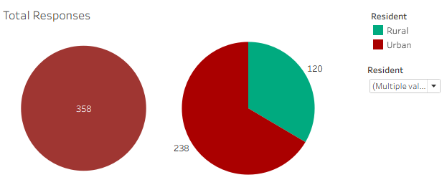
Note: Semi-urban and urban categories have been combined.

Section 2: Lifestyle Comparison
The survey reveals clear and consistent differences in work patterns, screen use, and sleep behavior between rural and urban residents. The following subsections detail these comparisons.

2.1 Work patterns
Rural respondents are more engaged in physical work, while urban respondents are primarily involved in mental or knowledge-based work. A higher proportion of urban respondents also report engaging in a combination of both work types.

Figure 2. Types of work participants do
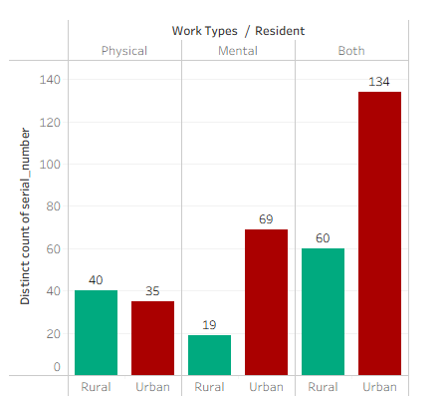

2.2 Core Comparative
Three core behavioral variables were measured: average working hours per day, average screen time before sleep hours, and average sleep duration hours per night. The following figures and comparative table summarize the results.

Urban respondents reported that they work slightly longer on average, while rural residents report marginally higher screen use before sleep and slightly longer sleep duration. The differences in sleep duration are minimal, suggesting sleep length alone is not the primary differentiator between groups.

Figure 3 Differences in Core Lifestyle between Residents

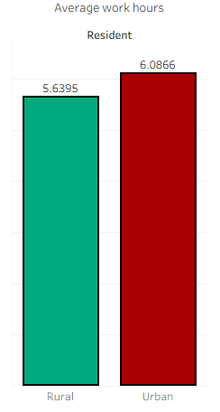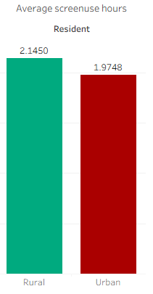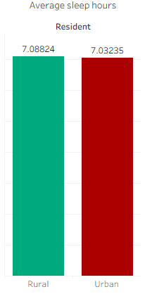

Section 3 Behavior relationship
This section examines the statistical relationships between the three core behavioral variables (working hours, screen use before sleep, and sleep duration) and outcomes: sleep quality and daytime energy levels.
Urban residents: Neutral as changes in working hours showed no clear effect on sleep quality or daytime energy. Rural residents: Negative as working hours increased, both sleep quality and daytime energy tended to decrease slightly, suggesting that longer working hours have a mild adverse effect on wellbeing in rural populations.

Figure 4. Average working hours with outcome
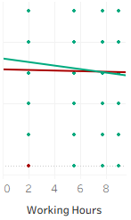
Urban and Rural residents: Negative as in both groups, greater screen use before sleep was associated with poorer sleep quality and lower daytime energy levels. This negative effect appeared more pronounced among rural residents, indicating that screen use before bedtime is a consistently harmful habit regardless of location.

Figure 5. Average screen use before sleep hours with outcome
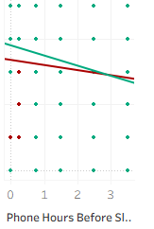
Urban residents: Neutral as longer sleep duration did not clearly improve sleep quality or daytime energy, suggesting that sleep length alone is not a reliable predictor of wellbeing in urban populations. Rural residents: Weakly Positive as longer sleep was associated with slightly better sleep quality and energy levels; however, the improvement was modest and not strongly conclusive.

Figure 6. Average sleep hours with outcome

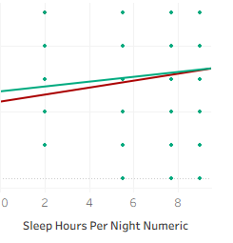

Improvement Strategies & Preferences
Respondents were asked to identify which habits they believe most contribute to better sleep quality. This insight directly informs product feature prioritization for a sleep-support application.

The top four habits are reduced screen-use, stress-free space, same sleep time, and relaxing activities.
Figure 7. Habits Believed to Improve Sleep Quality

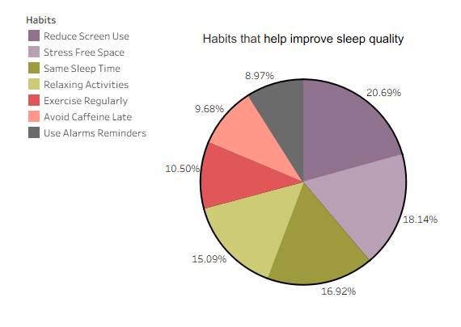

Market Opportunity (includes Unit Economics + Commercial Potential)
Respondents were asked to identify which features they would most value in a sleep-support mobile application. The results provide a ranked feature roadmap for product development:

The top four habits are reminders to reduce screen-use, sleep tracking, tips better bedtime and help manage schedules.
Figure 8. Support Features for a Sleep Application
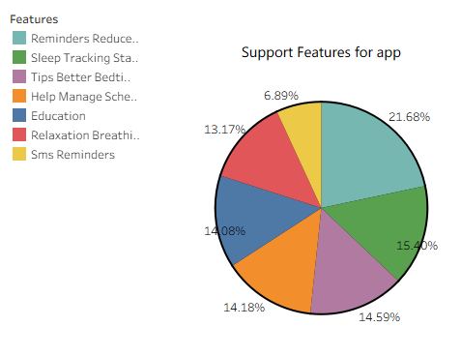

Market willingness and commercial potential
Respondents were asked directly whether they would be willing to use a sleep-support application with the features described above. The results indicate a strong commercial opportunity:

In terms of willingness to use such an app, a majority of respondents said they would be willing to try it. This indicates a strong potential interest in a sleep-support app, especially if it includes useful and relevant features.

Figure 9. Respondent Willingness to Use a Sleep-Support App Application
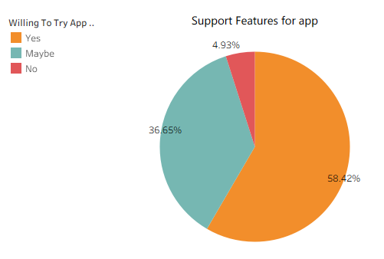

Proposed Solution
The findings identify the opportunities to develop digital solutions addressing sleep and lifestyle habits in Bhutan. In particular, the strong influence of work, screen-use before sleep and sleep patterns on sleep quality and daytime energy highlights the need for an integrated, user-friendly solution.
Based on these insights, the following commercially viable product solutions are proposed:
1. Benchmarking Platform (Comparison Tool)
A website can allow users to:
- Compare their habits (sleep, screen time, work hours) with others
- See whether they are above or below average
- Insights into how their habits relate to overall wellbeing
Value: This platform enhances user awareness and engagement by providing social and data-driven comparisons. It encourages behavior change by helping users understand their relative position and motivating them to improve.
2. Sleep and Lifestyle Management Mobile Application
- A mobile app can help users:
- Track sleep patterns
- Monitor screen use before bedtime
- Receive personalized recommendations
Value: This solution provides users with practical, data-driven insights to improve sleep quality and daytime energy. By combining multiple lifestyle factors into a single platform, the app offers a more comprehensive and personalized approach compared to existing solutions.
Future Development Potential
In the later stages, SomPel Tech can expand its offerings by introducing a “Healthy Habit Creator”, a behavior-change tool designed to:
- Support goal-setting and habit formation
- Provide reminders and progress tracking
- Guide users in building consistent daily routines
This feature will strengthen long-term user engagement and improve sustained behavior change, once the core mobile application and benchmarking platform are fully established.

Go-to-Market Strategy
SomPel Tech will focus on introducing its product in a simple and practical way, starting with users who are most likely to benefit from it. The main target users are students, working professionals, and smartphone users who often experience sleep problems due to screen use and busy schedules.
The product will be launched in phases. First, the benchmarking platform (comparison tool) will be introduced as a website where users can compare their habits such as sleep, screen time, and work hours with those of others. It will also allow users to see whether they are above or below average and understand how their habits relate to overall wellbeing. In addition, the platform will provide basic personalized recommendations based on users’ data. This will help increase awareness, offer guidance, and encourage users to improve their behavior.
Afterward, a sleep and lifestyle management mobile application will be developed and launched. The app will allow users to track their sleep patterns, monitor screen use before bedtime, and view simple statistics along with personalized recommendations. By combining multiple lifestyle factors in one place, the app will provide practical and continuous support to improve sleep quality and daily energy.
Later, more advanced features, such as habit-building tools, can be added to further support long-term behavior change. However, these advanced features may not be fully developed by June 12 and will be part of future improvements.
To reach users, SomPel Tech will primarily use social media platforms such as Facebook, Instagram, and TikTok to raise awareness about sleep and wellbeing. Simple and relatable content, such as tips for better sleep and the effects of screen use, will be shared to attract users. In addition, collaborations with schools, colleges, and workplaces can help introduce the app to a wider audience.
Overall, the strategy is to start small, build trust with users, and gradually grow by improving the product based on user needs and feedback.

Risk Register
- Low User Adoption
Users may be hesitant to adopt a new application due to lack of awareness or resistance to changing habits. This could limit the growth and effectiveness of SomPel Tech.
Mitigation: Conduct awareness campaigns, provide simple and user-friendly features, and collaborate with schools and workplaces to increase exposure and trust.

- Privacy Concerns
Users may be reluctant to share personal data such as sleep patterns, screen time, and daily habits due to privacy concerns.
Mitigation: Implement strong data protection measures, anonymize user data, and clearly communicate privacy policies to build trust with users.

- Limited Resources (Financial & Technical)
As an early-stage startup, SomPel Tech may face constraints in funding, technical expertise, and development capacity, which can delay progress.
Mitigation: Develop the product in phases, prioritize essential features first, and seek funding or partnerships to support development.

- Strong Competition
Established global applications in the sleep and wellbeing space may dominate the market, making it difficult to compete.
Mitigation: Focus on local relevance, personalized insights, and integration of lifestyle factors specific to Bhutan to differentiate the product.

- Data Accuracy and User Engagement
The effectiveness of the platform depends on users consistently inputting accurate data. Inconsistent or incomplete data may reduce the quality of insights.
Mitigation: Use reminders, simplify data entry, and design engaging features to encourage consistent user participation and improve data reliability.

Conclusions
This report has explored the relationship between daily lifestyle habits and sleep quality in Bhutan, and has used those findings to build the foundation of SomPel Tech as a business. The key takeaway is clear: the way people work, use their screens, and manage their daily routines has a direct impact on how well they sleep and how energized they feel each day.
The survey of 358 participants from urban, semi-urban, and rural areas confirmed that screen use before sleep is consistently harmful to sleep quality and daytime energy, regardless of where someone lives. Urban residents work more and engage in knowledge-based tasks, while rural residents tend to sleep slightly longer and stay more physically active. In both groups, healthier behaviors such as reducing screen time, maintaining a consistent sleep schedule, and creating a relaxing bedtime environment were identified as the most effective ways to improve sleep.
The competitive analysis showed that while many global applications address sleep or screen use separately, none of them fully combine these lifestyle factors into a single, accessible, and locally relevant solution. This is exactly the gap that SomPel Tech aims to fill. With over 55% of survey respondents saying they would be willing to use a sleep-support application, there is a clear and genuine demand for this kind of product in Bhutan.
SomPel Tech plans to launch in two phases. The first will be a benchmarking website where users can compare their habits with others and get simple, personalized insights. The second will be a mobile application that allows users to track their sleep, screen use, and daily routines while receiving practical recommendations. Both products are designed to be easy to use, relevant to the Bhutanese context, and scalable over time.
As a sole founder at an early stage, SomPel Tech faces real challenges including limited resources, competition from established global platforms, and the need to build user trust. However, the strong local focus, data-driven approach, and genuine personal commitment behind this venture give it a meaningful advantage. The name SomPel itself, drawn from the values of merit, purpose, and prosperity, reflects the spirit in which this company was created: to do meaningful work that makes a positive difference in people’s lives.
In summary, SomPel Tech is well-positioned to address a real and growing problem in Bhutan. With a clear product roadmap, research-backed insights, and a user-centered approach, the startup has the potential to become a trusted digital health and wellbeing solution for individuals across the country.

References
Sithey, G., Wen, L. M., Kelly, P., & Li, M. (2017). Association between Sleep Duration and Self-Reported Health Status: Findings from the Bhutan’s Gross National Happiness Study. Journal of Clinical Sleep Medicine, 13(01), 33–38. https://doi.org/10.5664/jcsm.6382
Stauder, M., Vogel, A. C., Nirola, D. K., Tshering, L., Dema, U., Dorji, C., Dorji, L., & Mateen, F. J. (2020). Depression, sleep quality, and social isolation among people with epilepsy in Bhutan: A cross-sectional study. Epilepsy & Behavior, 112, 107450. https://doi.org/10.1016/j.yebeh.2020.107450
Dorji, N., Dunne, M. P., Seib, C., & Dep, S. (2018). Health-related quality of life and co-morbidities among older adults in Bhutan. Bhutan Health Journal, 4(2), 15–24. https://doi.org/10.47811/bhj.63
Gyeltshen, D., Gyaltshen, K., Dorji, N., Yangdon, K., Wangchuk, N., & Drakpa, L. (2023). Nurses’ napping practices and their effects on sleepiness, fatigue, well-being, and quality of nursing care. Nursing Practice Today, 10(2), 138–146. https://doi.org/10.18502/npt.v10i2.12834
Naveed, S., Waqas, A., Chaudhary, A. M. D., Kumar, S., Abbas, N., Amin, R., Jamil, N., & Saleem, S. (2020). Corrigendum: Prevalence of Common Mental Disorders in South Asia: A Systematic Review and Meta-Regression Analysis. Frontiers in Psychiatry, 11. https://doi.org/10.3389/fpsyt.2020.602062
Deivendran, G., Kanagaraj, T. S., Leelabai, B. S., Kannan, P., Srinivasan, Y., Ayyavoo, S., & Periasamy, P. (2025). Impact of Excessive Screen Time on Sleep Quality and Sleep Disturbances Among Young Adults: A Cross-Sectional Study. Journal of Pharmacy & Bioallied Sciences, 17(2), 53–55. https://doi.org/10.4103/jpbs.jpbs_944_25
‌Vector of workaholic men in office until late night | Premium AI ... (2026). Bing. https://sl.bing.net/eOuWCyiIoIC
Woman lying in bed at night using cellphone 25943507 Vector Art at Vecteezy. (2026). Bing. https://sl.bing.net/jlV1DKDwKmO
Premium Vector | Insomnia and sleep disorder concept addiction of ... (2026). Bing. https://sl.bing.net/hZonEeRzno
Cumberland County Public Health Division. (n.d.). Minority health assessment report. Retrieved from 4c58ecc5-9b69-4459-9ff6-1594575b2755

Appendix
Note: Click link to access documents.
Appendix A: Survey Questionnaire
https://drive.google.com/file/d/1SpLhGcjsqUK8I7Ce7KV7IumZj1HjCeLM/view?usp=sharing

Appendix B: Data
https://docs.google.com/spreadsheets/d/1J2D-m9KAjTvoE9ayLEJPSkzSfXIwGW6O/edit?usp=sharing&ouid=117906368688119609935&rtpof=true&sd=true

Appendix C: Tableau
https://drive.google.com/file/d/1oXIbnLS-RTPfqG2BAa6uuHWtITnyI4W_/view?usp=sharing

Appendix D: Product
BDS-Planio-githup/Phendhey-Tech/Web/Execute at main · saypel44/BDS-Planio-githup
Deploy link:

